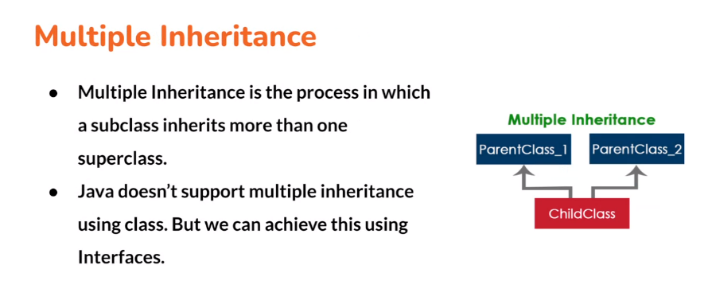

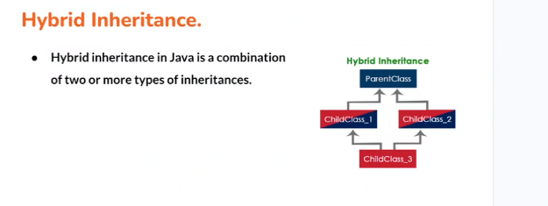

Create an ec2 instance for a reactjs application and deploy the application and provide the public ip for it,also enable the cloud monitoring.

Single inheritance,hierarchial,multi level ,achieving multiple inheritance using interfaces